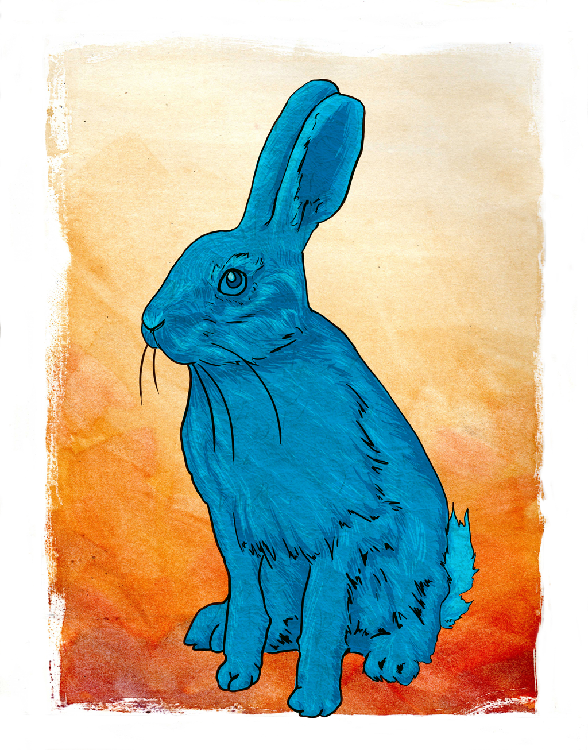
Resources you can use:

BBC Bitesize of Mice and Men revision
Spark notes
Revision world
York notesa digital copy of the novel is attached.
Of Mice & Men
By John Steinbeck-1937

John Steinbeck
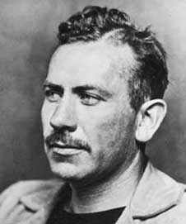
John Steinbeck
John Steinbeck was born in Salinas, California in 1902. Although his family was wealthy, he was interested in the lives of the farm labourers and spent time working with them. He used his experiences as material for his writing.
He wrote a number of novels about poor people who worked on the land and dreamed of a better life, including The Grapes of Wrath, which is the heart-rending story of a family's struggle to escape the dust bowl of the West to reach California. Steinbeck was awarded the Nobel Prize for Literature in 1962, six years before his death in 1968.

Most of Steinbeck's work is set in southern and central California, particularly in the Salinas Valley and the California Coast Ranges region. His works frequently explored the themes of fate and injustice, especially as applied to downtrodden or everyman protagonists. Steinbeck once said of his writing:

“For too long the language of books was different from the language of men. To the men I write about profanity is adornment and ornament and is never vulgar and I try to write it so.”
Of Mice and Men- The title.
John Steinbeck takes the title of this novel from the poem "To a Mouse [on turning her up in her nest with the plough]," written by Scottish poet Robert Burns in 1785.
In the poem, the speaker has accidentally turned up a mouse's nest with his plough. He pauses for a little rumination about how men and animals might seem different, but in the end they're all mortal. No matter how different "thinking men" and "unthinking animals" seem, everybody suffers and dies in the end:
But, Mousie, thou art no thy lane [alone]
In proving foresight may be vain:
The best-laid schemes o' mice an' men
Gang aft agley, [often go awry]
An' lea'e us nought [leave us nothing] but grief an' pain,
For promised joy.
But there is one difference. Mice and men might both die, but only the men are aware of it. In the last verse of the poem, Burns's speaker says that the mouse is "blest":
Still thou art blest, compar'd wi' me!
The present only toucheth thee:
But, och! I backward cast my e'e [eye]
On prospects drear! [dreary]
An' forward, tho' I canna [cannot] see
I guess an' fear!
In other words, the mouse can't think about the past or the future. Does this remind you of anyone? Us, too. It seems like Steinbeck is thinking of Lennie as the mouse, and George as the man who turns up its nest: life messes them both up, but at least Lennie doesn't have to remember any of it. Whatever happens to Lennie is over. He doesn't regret anything and he doesn't anticipate anything—not even his death.
But not George. George will have to live with what he's done for the rest of his life.
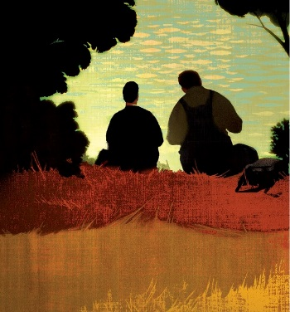

How do you think the title gives us clues on what the tone of the story is going to be? Do you agree with Steinbeck’s comment on life? Why/why not? (5 Mins)
……………………………………………………………………………………………………………………………………………………………………………………………………………………………………………………………………………………………………………………………………………………………………………………………………………………………………………………………………………………………………………………………………………………………………………………………………………………………………………………………………………………………………………………………………………………………………………………………………………………………………………………………………………………………………………………………………………………………………………………………………………………………………………………………………………………………...
Naturalist Writing…
Of Mice and Men employs a very particular type of realism called "naturalism," a type of literature where the narrator looks at the characters as though they're scientific specimens: objectively and dispassionately. Naturalist novels often depict the world as a place where you have to fight to survive in a universe that has no morality and doesn't care about you. This type of writing became more prominent during 1880s to 1930s and was heavily influenced by Darwin’s theory of evolution; believing that one's heredity and social environment largely determine one's character.
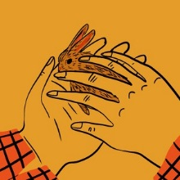
Cheerful stuff, right? The strength of realism is that you don't need to be sold with emotional bells and whistles—the lives of people alone are enough to move you.

Look up these five aspects to naturalist writing. Write a brief summary of each of them and the role they play in this style of writing:
- Determinism
………………………………………………………………………………………………………………………………………………………………………………………………………………………………………………
- Detached narrator
………………………………………………………………………………………………………………………………………………………………………………………………………………………………………………
- Pessimism
………………………………………………………………………………………………………………………………………………………………………………………………………………………………………………
- Nature
………………………………………………………………………………………………………………………………………………………………………………………………………………………………………………
- Darwinsim
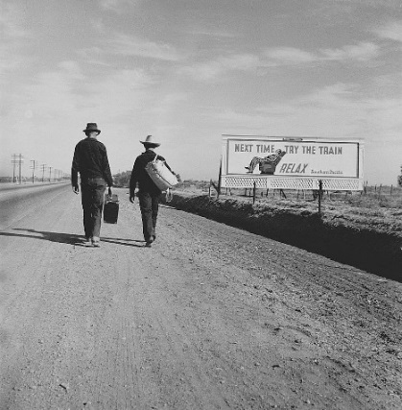
………………………………………………………………………………………………………………………………………………………………………………………………………………………………………………

Summarise how Steinbeck’s use of naturalist writing sets the tone of the first chapter using, point, evidence, explain. (10 Mins)
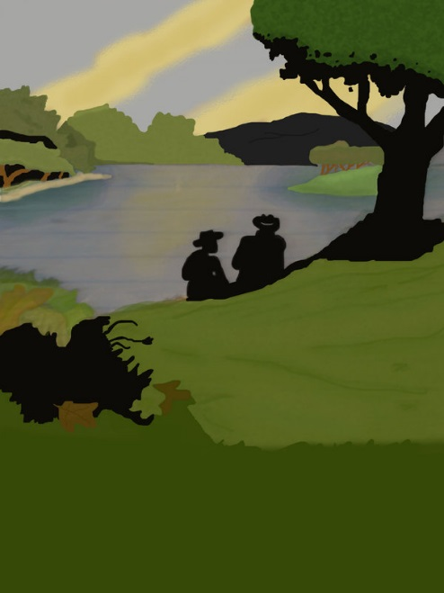
……………………………………………………………………………………………………………………………………………………………………………………………………………………………………………………………………………………………………………………………………………………………………………………………………………………………………………………………………………………………………………………………………………………………………………………………………………………………………………………………………………………………………………………………………………………………………………………………………………………………………………………………………………………………………………………………………………………………………………………………………………………………………………………………………………………………………………………………………………………………………………………………………………………………………………………………………………….
……………………………………………………
……………………………………………………
……………………………………………………
……………………………………………………
……………………………………………………
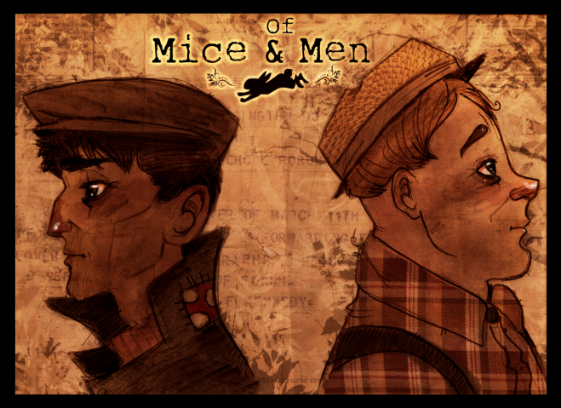
Any key words, phrases or ideas from Chapter One:

Character Study:
Write a short summary on each character, include at least one quote to back up your summary.
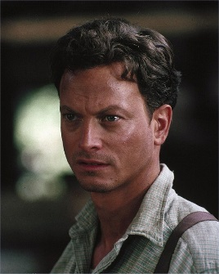
GEORGE:

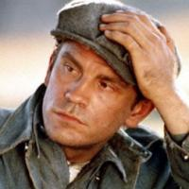
LENNIE:

CURLEY:
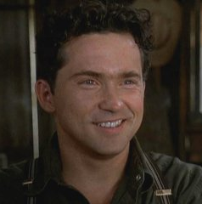

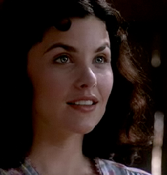
CURLEY’S WIFE:

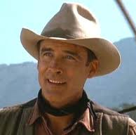
SLIM:

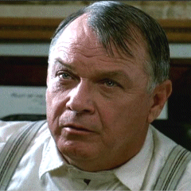
THE BOSS:
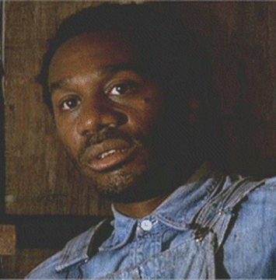
CROOKS:

CANDY:
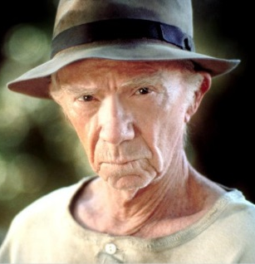

CARLSON & WHIT:

How does Steinbeck use language in this chapter to clearly introduce the characters and create tension?
……………………………………………………………………………………………………………………………………………………………………………………………………………………………………………………………………………………………………………………………………………………………………………………………………………………………………………………………………………………………………………………………………...............................................................................................................................................................................................
Hero and Villain: What evidence do we already have that Slim is a hero and Curley is a villain?
Curley
Slim

Migrant farmers:
Added to the man-made financial problems were natural ones. A series of droughts in southern mid-western states like Kansas, Oklahoma and Texas led to failed harvests and dried-up land. Farmers were forced to move off their land: they couldn't repay the bank-loans which had helped buy the farms and had to sell what they owned to pay their debts.
Many economic migrants headed west to 'Golden' California, thinking there would be land going spare, but the Californians turned many back, fearing they would be over-run. The refuges had nowhere to go back to, so they set up home in huge camps in the California valleys - living in shacks of cardboard and old metal - and sought work as casual farmhands.
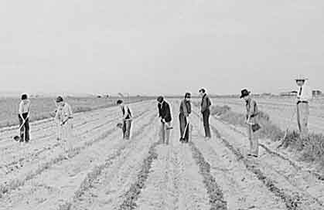

Ranch Hands:
Against this background, ranch hands like George and Lennie were lucky to have work. Ranch hands were grateful for at least a bunk-house to live in and to have food provided, even though the pay was low.
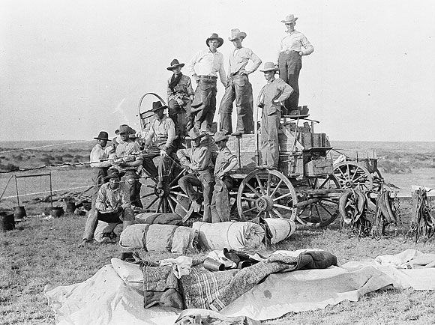

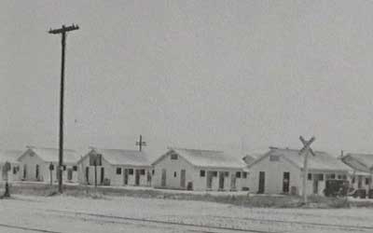

Farmworkers' bunkhouses

Think about how the men agree to hush-up the fight between Curley and Lennie and claim that Curley got his hand caught in a machine: they know that Lennie and George would be fired if the boss came to hear of it, and then Lennie and George could be left with nothing.

Think about how Steinbeck has used this lifestyle to comment on the American Dream

Dramatic Tension in Section Three

Look at chapter 2

What word does Steinbeck repeat frequently in this chapter to show the tension in the bunkhouse when Carlson takes Candy’s dog away to shoot it. Give two sentences to illustrate this.

……………………………………………………………………………………………………………………………………………………………………………………………………………………………………………………………………………………………………………………………………………………………………………………………………………………………………………………………………………………………………………

How do George and Slim try to ease the tension?

……………………………………………………………………………………………………………………………………………………………………………………………………………………………………………………………………………………………………...

How does Candy react when he hears the shot? Why?

……………………………………………………………………………………………………………………………………………………………………………………………………………………………………………………………………………………………………………………………………………………………………………………………………………………………………………………………………………………………………………

This episode features a lot of physical action and violence, and Steinbeck again uses animal imagery in his description. Find two examples.

1)…………………………………………………………………………………………………………………………………………………………………………………………………
2)…………………………………………………………………………………………………………………………………………………………………………………………………

Why do you think George encourages Lennie to fight (“Get ‘im, Lennie!) at first, but then restrains him (“Leggo his hand, Lennie”) and even starts slapping him?

……………………………………………………………………………………………………………………………………………………………………………………………………………………………………………………………………………………………………………………………………………………………………………………………………………………………………………………………………………………………………………

Why do you think Curley agrees he won’t tell at the end of this episode?

……………………………………………………………………………………………………………………………………………………………………………………………………………………………………………………………………………………………………………………………………………………………………………………………………………………………………………………………………………………………………………
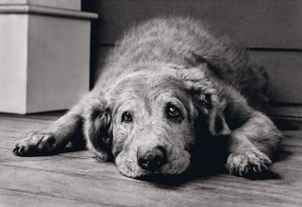
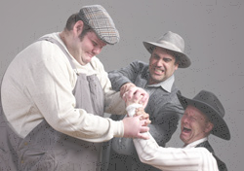

How does Steinbeck use foreshadowing in this section to add to the impending tragedy? Find any quotes that show this technique and explain what they are foreshadowing:
Foreshadowing Quote: | What it is foreshadowing: | Why is this effective?

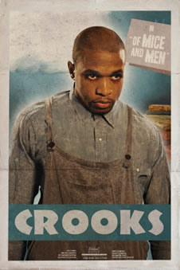
Loneliness & Outsiders in Section 4:

Research: Find 5 things that all black people were not able to do in 1930s America and 5 things all women were not able to do: (10 Mins)
1………………………………………………………………………………………………
………………………………………………………………………………………………..
2……………………………………………………………………………………………..
………………………………………………………………………………………………..
3……………………………………………………………………………………………..
….…………………………………………………………………………………………….
4………………………………………………………………………………………….....
…………………………………………………………………………………………………
5………………………………………………………………………………………………
…………………………………………………………………………………………………
1………………………………………………………………………………………………
………………………………………………………………………………………………..
2……………………………………………………………………………………………..
………………………………………………………………………………………………..
3……………………………………………………………………………………………..
….…………………………………………………………………………………………….
4………………………………………………………………………………………….....
…………………………………………………………………………………………………
5………………………………………………………………………………………………
…………………………………………………………………………………………………
What do we learn about Crooks? List each of the items Steinbeck describes and note what these items reveal about Crooks’ character.

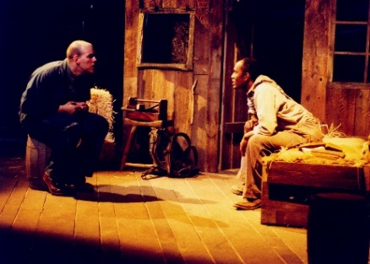
……………………………………………………………………………………………………………………………………………………………………………………………………………………………………………………………………………………………………………………………………………………………………………………………………………………………………………………………………………………………………………………………………………………………………………………………………………………………………………………………………………………………………………………………………………………………………………………………………………………

What other clues does Steinbeck give to Crooks’s character? Why do you think Crooks is ‘a proud, aloof man. [who] kept his distance and demanded other people kept theirs’ (10 Mins)
……………………………………………………………………………………………………………………………………………………………………………………………………………………………………………………………………………………………………………………………………………………………………………………………………………………………………………………………………………………………………………………………………………………………………………………………………………………………………………………………………………………………………………………………………………………………………………………………………………………
……………………………………………………………………………………………………………………………………………………………………………………………………………………………………………………………………………………………………………………………………………………………………………………………………………………………………………………………………………………………………………………………………………………………………………………………………………………………………………………………………………………………………………………………………………………………………………………………………………………
How does Steinbeck use the themes of ‘loneliness’ and ‘being an outsider’ to create a more rounded view of Curley’s wife? Give some quotes to back you interpretation up. (10 mins)
……………………………………………………………………………………………………………………………………………………………………………………………………………………………………………………………………………………………………………………………………………………………………………………………………………………………………………………………………………………………………………………………………………………………………………………………………………………………………………………………………………………………………………………………………………………………………………………………………………………
……………………………………………………………………………………………………………………………………………………………………………………………………………………………………………………………………………………………………………………………………………………………………………………………………………………………………………………………………………………………………………………………………………………………………………………………………………………………………………………………………………………………………………………………………………………………………………………………………………………
Things go Wrong-Section 5:

“I believe a strong woman may be stronger than a man, particularly if she happens to have love in her heart. I guess a loving woman is indestructible.”
(Steinbeck)

What do you think Steinbeck thought of women through his presentation of women in the book?
……………………………………………………………………………………………………………………………………………………………………………………………………………………………………………………………………………………………………………………………………………………………………………………………………………………………………………………………………………………………………………………………………………………………………………………………………………………………………………………………………………………………………………………………………………………………………………………………………………
How is sound and light used in this section to create a dramatic atmosphere? What other techniques does Steinbeck use?
Sound | Light | Other Techniques

Which do you think is most effective? Why?

