YEAR 10
REVISION ACTIVITIES
POWER AND CONFLICT POETRY REVISION

This booklet has been designed to help you revise the poems in the AQA Power and Conflict cluster from your poetry anthology at home. Work your way through the activities in the booklet. You can fill these out on the computer or print the booklet off and hand write your answers.
On various pages there will be directions to other resources you can find online to help you with your studies. If you do not have access to a computer, please do not worry! The most important things you need to know have been set out for you here.

‘THE CHARGE OF THE LIGHT BRIGADE’
The Charge of the Light Brigade
This session will be based around ‘The Charge of the Light Brigade’ by Alfred, Lord Tennyson. Some of the activities will require you to make notes in this booklet or on a different piece of paper. When you begin to annotate the poem, you can do this in your copies of the poetry anthology if you wish. We will go through these poems again in class when you return to address any misconceptions you might have made. If you have any questions, email your teacher who will get back to you as soon as they can.
Activity #1 – Pre-reading activities
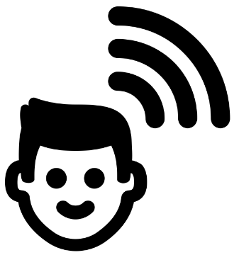
Spend no more than five minutes on this activity. Consider the title of the poem. Predict what big ideas the poem will explore by completing the following activities. Write your answers as annotations around the title:
- A ‘brigade’ is a military formation. What kind of ideas do you think the poem will explore?
- Highlight the word ‘charge’. What does this tell you about the movements of the brigade? What other ideas do you think the poem will explore based on this word?
- What is the effect of the word ‘the’? Why not ‘A Charge’?

MAKE PREDICTIONS

The Charge of the Light Brigade

Spend no longer than five minutes on this activity. ‘The Charge of the Light Brigade’ is about a particular battle fought in the Crimean War called the ‘Battle of Balaclava’. Below are a series of paintings depicting this battle. Make notes around each of the paintings detailing:
- what each painting tells you about the battle.
- what predictions you have made from each one.
- how the men are portrayed in them.
- what each picture makes you think of.
Look at the example to help you.

INFERENCES FROM ART

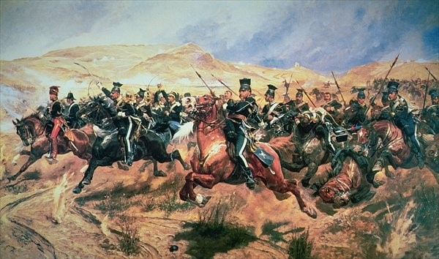
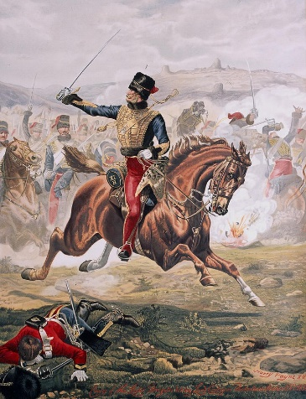
This soldier has his weapon raised, ready to attack, suggesting he is brave.

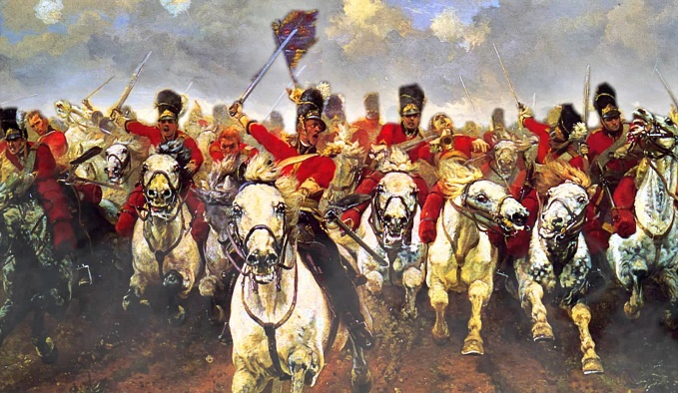

Spend no more than five minutes on this activity. ‘The Charge of the Light Brigade’ is by Alfred, Lord Tennyson. Read the contextual information below. Reduce the information into four bullet points to help you understand what influenced Tennyson’s writing. As you read, consider whether any of your inferences from the activities on the previous page were correct.

The Crimean War was fought between Britain and Imperial Russia from 1853-1856. For the first time in history, newspapers carried eye-witness reports as well as detailing not just the triumphs of war but the mistakes and horrors as well. The most significant moment in the Crimea came during the Battle of Balaclava. An order given to the British army's cavalry division (known as the Light Brigade) was misunderstood and 600 cavalrymen ended charging down a narrow valley straight into the fire of Russian cannons. Over 150 British soldiers were killed, and more than 120 were wounded. At home the news of the disaster was a sensation and a nation that had until then embraced British military exploits abroad began to question the politicians and generals who led them.

SUMMARISE THE INFORMATION
3.

4.

1.

2.

Activity #2 – Read the article
On the next page is a real newspaper article reporting on the events of the Battle of Balaclava. I would like you all to read the report and highlight any words/phrases/sentences used to describe the brigade and their actions. Completion of the grid below is optional. If you complete the grid, this will take you over your 90 minute slot for today’s lesson BUT don’t let that put you off. Remember, if you are aiming for higher grades, try and push yourself as much as you can!
Having read the newspaper article, complete the grid below:
In this box, summarise what the newspaper is saying about the Light Brigade. | In this box, pick a quotation from the report which describes the Light Brigade and complete single word analysis on the language used.
Having read the article and completed the activities at the beginning of this booklet, write down everything you have learned about the Light Brigade and the Battle of Balaclava in full sentences.

THE CHESTER CHRONICLE
18th November 1854

CHARGE OF THE LIGHT CAVALRY BRIGADE
back, rejoining some of his brigade who had reformed and charging again without sword or pistol. Mr. Cook, of the 1th, also had a regular run for his life of a mile and a half, pursued by the Russian cavalry, to avoid who he ran under range of the guns of one of their batteries, and finally escaped. Major Clarke, of one of the Grays, in addition to a bad cut in the neck, had his horse’s tail almost cut off by a sabre cut; and I hear the gallant Adjutant Miller, an unusually powerful man, did extraordinary execution where he got to close quarters with them.
THE MELEE
However, there was no hesitation; down our fellows went at the gallop, through a fire in front and on both flanks, which emptied our saddles and knocked over our horses by scores. I do not think that one man flinched in the whole brigade, though everyone allows that so hot a fire was hardly ever seen. We went right on, cut down the gunners at their guns (the Russians worked their guns till we were within ten yards of them) went on still, broke a line of cavalry in rear of the guns, and drove it back on the third line. But here our bolt was shot; the Russians formed four deep, and our thin and broken ranks and blown horses could not attempt to break through them, particularly as the Russian cavalry had got round our flanks, and were prepared to charge our rear (with fresh men.) We broke back through them, however, and then had to run the gauntlet through the cross-fire of artillery and rifles back to our own lines, with their cavalry hanging on our flanks. The heavy brigade, which made a good charge of its own in the morning, covered our coming out of action and lost some men from the artillery.

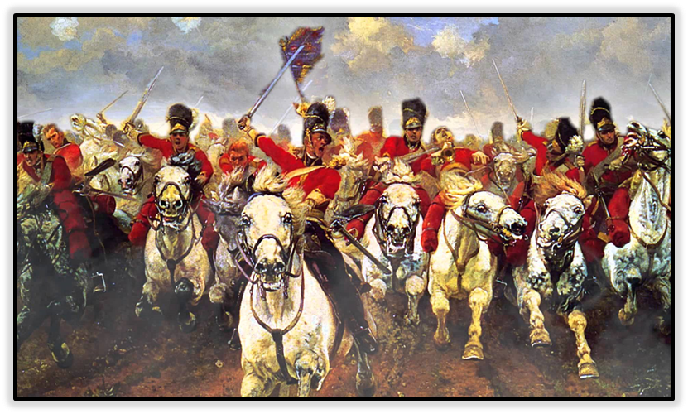

The Light Brigade kept sweeping on till they were right in front of them, when a 32-pounder went off within two feet of Lod Cardigan’s hose, quite lifting him off the ground, but he got in among them, and was, where he always will be when it comes to the point, in the first rank. It seems the rode right through the guns and turned, after killing the men who were serving them. His Lordship’s extra aide-de camp, it is supposed, was wounded and taken prisoner, for he has not since been heard of. Mr. Wombwell, of the 17th Landers had a most extraordinary escape, showing a monstrous deal of pluck. His horse was- it is said two were-shot under him, and he was taken prisoner, but while being marched off he saw an opportunity, mounted a Russian’s horse and galloped

The charge of the Light Brigade of Cavalry on the batteries of the enemy, some 30 guns strong, though brilliantly and bravely done, was most disastrous in its consequences to that gallant and devoted band, for it seems that out of 700 who went into the fray only 130 answered their roll when it was over; and it appears to have been done under a misapprehension of an order from the Commander-in-Chief. Lord Cardigan pointed out his superior officer the immense difficulty of charge a batter, flanked by another, into a sort of cul de sac, with the hulls lined with Rifles and guns but receiving the positive order to charge, as it he and his splendid brigade went, and as they approached within a few hundred yards of the big battery a shell burst close to him, and struck Captain Nolan in the chest, which caused the poor fellow to scream awfully, and his horse turned and galloped to the rear, where his gallant but impetuous rider was found lying dead.

Activity #3 – Read the poem
Spend no longer than ten minutes on this activity. Read the poem and answer the questions that follow in full sentences. If you need help understanding the poem, try the Shmoop link. Do your best to answer the questions without extra help before you look elsewhere for information: https://www.shmoop.com/study-guides/poetry/charge-of-light-brigade-poem

1.
Half a league, half a league,
Half a league onward,
All in the valley of Death
Rode the six hundred.
"Forward, the Light Brigade!
Charge for the guns!" he said:
Into the valley of Death
Rode the six hundred.

2.
"Forward, the Light Brigade!"
Was there a man dismay’d?
Not tho’ the soldier knew
Some one had blunder’d:
Theirs not to make reply,
Theirs not to reason why,
Theirs but to do and die:
Into the valley of Death
Rode the six hundred.
3.
Cannon to right of them,
Cannon to left of them,
Cannon in front of them
Volley’d and thunder’d;
Storm’d at with shot and shell,
Boldly they rode and well,
Into the jaws of Death,
Into the mouth of Hell
Rode the six hundred.
4.
Flash’d all their sabres bare,
Flash’d as they turn’d in air
Sabring the gunners there,
Charging an army, while
All the world wonder’d:
Plunged in the battery-smoke
Right thro’ the line they broke;
Cossack and Russian
Reel’d from the sabre-stroke
Shatter’d and sunder’d.
Then they rode back, but not
Not the six hundred.
5.
Cannon to right of them,
Cannon to left of them,
Cannon behind them
Volley’d and thunder’d;
Storm’d at with shot and shell,
While horse and hero fell,
They that had fought so well
Came thro’ the jaws of Death,
Back from the mouth of Hell,
All that was left of them,
Left of six hundred.
6.
When can their glory fade?
O the wild charge they made!
All the world wonder’d.
Honor the charge they made!
Honor the Light Brigade,
Noble six hundred!

1

30
5

35

10

40
15

45

20

50
25

55

- What is happening in this poem? Explain your ideas in no more than four sentences.

- How does Tennyson present the ‘six hundred’ men of the Light Brigade? Explain in no more than four sentences.
Activity #4 – Clarifying tricky vocabulary
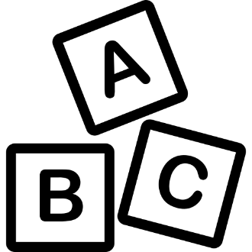
Spend no longer than twenty minutes on this activity. Some of the words in the poem are quite complex. Write the definitions for each word and explain what they mean in the poem’s context. Look at the example below to help you. Once you have finished adding your definitions, check the answers in the back of the booklet immediately to avoid any errors and misconceptions. There will be a chance for you to visually represent each word at the end of this activity as well.

CLARIFY TRICKY VOCABULARY

An example:
Word | Add the definition | Read the word in context | What does the line mean?
league | An old way of measuring distance, equal to about three miles. | ‘Half a league, half a league, half a league onward’ | The speaker is highlighting a sense of urgency, showing how the ‘six hundred’ kept going, galloping a mile and a half.
blunder’d |  | ‘Some one had blunder’d’
volley’d |  | ‘Cannon in front of them / Volley’d and thunder’d’
sabres |  | ‘Flash’d all their sabres bare’
Cossack |  | ‘Cossack and Russian / Reel’d from the sabre-stroke’
sunder’d |  | ‘Reel’d from the sabre-stroke / Shatter’d and sunder’d.’
Extension: Create an icon (visual representation) of each word in the space below to help your understanding of the language used in the poem.

Activity #5 – Find it, Highlight it, Annotate it
Spend no longer than forty minutes on this activity. You may complete this activity by annotating the copy of the poem in this booklet OR in your poetry anthology if you have it with you. If you run out of space, feel free to print another copy of the poem off OR write on a different piece of paper. We will go through this again in class so please do not worry about missing anything. Complete the ‘find it, highlight it, annotate it’ task by looking at the line number each question directs you to, highlighting what is needed and answering the questions as annotations on your poem. If you miss any questions out, that’s fine BUT underline, circle or highlight ones you need to come back to later.
- Lines 1 and 2 – Highlight every time ‘half a league’ is mentioned – What language device is this and what is Tennyson saying about how the soldiers are arriving to the battle on their horses?

- Line 3 – Highlight ‘valley of death’ – How has Tennyson made the valley sound? EXTRA CHALLENGE: How is religion alluded to in this line?

- Line 4 – Highlight this line. How does Tennyson present the Light Brigade as a collective force and why does Tennyson want to present the Brigade as one force?

- Lines 5 and 6 – Imperatives are commands. Highlight the imperatives in these lines and label them as such – What do these imperatives tell us about those leading the battle?

- Line 7 – Underline ‘valley of death’ – Explain why you think Tennyson may have repeated this line. What effect does he want to create?

- Line 10 – Highlight this line – What language device is this and what is actually being asked about the soldiers who have gone into battle?

- Line 12 – Circle this line – The soldiers are heading into battle but Tennyson says here that the person who gave them these orders has ‘blunder’d’. What does this mean and why do you think this line is indented?

- Lines 13-14 – Underline the anaphora (where the line begins the same and ends differently) – What is Tennyson saying about the soldiers and their views on what they are being asked to do in these lines?

- Line 15 – Circle this line – What is the sole purpose of the soldiers?
10. Line 17 – Highlight this line – Why do you think Tennyson keeps repeating ‘six hundred’?
11. Lines 18-20 – Circle the anaphora – What is Tennyson saying about what the soldiers are up against in their fight?
12. Line 22 – Circle every time there is an ‘s’ in this line – Repeated ‘s’ sounds are called sibilance. Try saying the line out loud to yourself. What sound is created and why does Tennyson want to create it here?
13. Line 23 – Highlight ‘boldly’ – How does this adverb present the soldiers?
14. Lines 24-25 – Highlight the personification in this line – What effect do ‘jaws’ and ‘mouth’ create? How do they make the battle sound?
15. Lines 27-33 – Highlight all the verbs (actions) in this section – Explain how they make the ‘six hundred’ sound when they are fighting and why Tennyson wants to present them in this way?
16. Lines 36-37 – No need to highlight anything – Explain what is happening to the Cossack and Russian forces here.
17. Lines 42-43 – Highlight both uses of ‘and’ – Why does Tennyson use ‘and’ in these two lines? What are the ‘six hundred’ experiencing?
18. Line 44 – Highlight this line – What is happening to the ‘six hundred’? Why refer to them as heroes?
19. Lines 46-47 – Underline the personification used here – What is Tennyson saying war does through his use of personification?
20. Lines 48-49 – No need to highlight anything – Even when some of the soldiers have died, Tennyson still refers to them as ‘six hundred’. Why?
21. Lines 50-55 – No need to highlight anything – The focus changes from the horrors of war to something else. What is it?
22. Lines 53-54 – Highlight ‘honour’ – Why does Tennyson command us to honour these soldiers?
23. Line 55 – Highlight ‘noble’ – What does this adjective make the ‘six hundred’ sound like?

Activity #6 – YouTube Analysis
This activity is optional but if you are aiming for a grade 7 or above, you should try and complete it if you have access to the internet. Follow this link: https://www.youtube.com/watch?v=4bIvQlXx1Ws. It will take you to a video by ‘Mr. Salles Teaches English’ on YouTube. The ideas he discusses are complex but will help you consider what is needed for grades 7-9. You DO NOT need to watch the entire video but you can if you want. Pay particular attention to the topics in the grid and make notes. I have provided the times for you. Completing this activity will take you over your 90 minute slot so I will stress again that it is optional.

General Information (from 11 minutes, 52 seconds) | Rhyme Scheme (from 13 minutes, 38 seconds)
Dactyls (from 23 minutes, 2 seconds) | Any other information
Summarise your notes from the video into four key points:
1.

2.

3.

4.

Activity #7 – Themes
Spend no longer than ten minutes on this section.
Themes:
Consider the ‘big ideas’ explored in Tennyson’s ‘The Charge of the Light Brigade’. Tick the ones you think apply to the poem and briefly explain your choices below.

Individual Experience
Identity
Negative Emotions - Pride
Negative Emotions - Fear
Negative Emotions - Guilt
Negative Emotions - Anger
Power of Humans

Power of Nature

Effects of Conflict

Reality of Conflict

Loss and Absence

Memory

Briefly explain your choices in full sentences:
____________________________________________________________________________________________________________________________________________________________________________________________________________________________________________________________________________________________________________________________________________________________________________________________________________________________________________________________________________________________________________________________________________________________________________________________________________________________________________________________________________________________________________________________________________________________________________________________________________________________________________________________________________________________________________________________________________________________________________________________________________________________________________________________________________________________________________________________________________________________________________________

Answers

Vocabulary
CLARIFY TRICKY VOCABULARY
Mark your answers to the vocabulary activity. Your definition does not need to be worded exactly as it is here but you should be able to tell whether you have the correct answer or not.

Word | Add the definition | Read the word in context | What does the line mean?
blunder’d | A stupid or careless mistake. | ‘Some one had blunder’d’ | Someone had made a careless mistake in giving orders for the soldiers to ride into the valley.
volley’d | Lots of gunfire in the air at the same time. | ‘Cannon in front of them / Volley’d and thunder’d’ | Cannons were being fired everywhere, thundering through the air.
sabres | A heavy sword with a curved blade. | ‘Flash’d all their sabres bare’ | The men are holding their swords high as they charge into battle.
Cossack | Free warrior-peasants of chiefly East Slavonic descent who lived in communes, especially in Ukraine, and served as cavalry under the Russian tsars. | ‘Cossack and Russian / Reel’d from the sabre-stroke’ | The warriors serving the Russians fell back from the strokes of the British swords.
sunder’d | Separated or split by something. | ‘Reel’d from the sabre-stroke / Shatter’d and sunder’d.’ | The Cossacks and the Russians were separated by the strokes of the British swords.

Themes
These are the THREE main themes that ‘The Charge of the Light Brigade’ relates to. If you ticked something else, ensure you correct it in your booklet and amend your written answer too.

Individual Experience
Identity
Negative Emotions - Pride
Negative Emotions - Fear
Negative Emotions - Guilt
Negative Emotions - Anger
Power of Humans

Power of Nature

Effects of Conflict

Reality of Conflict

Loss and Absence

Memory

