YEAR 9
REMOTE LEARNING ACTIVITIES
POWER AND CONFLICT POETRY
PRE READING ACTIVITIES
Name:
Class:
Teacher:
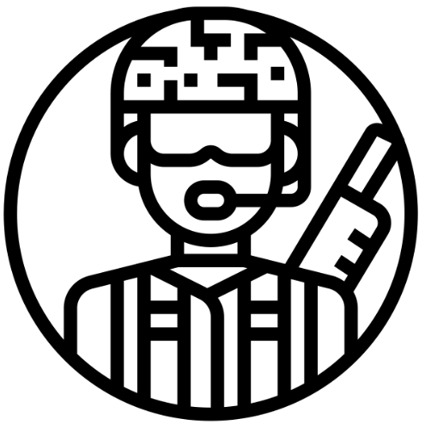

This booklet has been designed to help you learn the poems in the AQA Power and Conflict cluster from home. Work your way through the activities in the booklet.
You can fill these out on the computer or print the booklet off and hand write your answers. On various pages there will be directions to other resources you can find online to help you with your studies. If you do not have access to a computer, please do not worry! The most important things you need to know have been set out for you here.

Remains
‘REMAINS’
This session will be based around ‘Remains’ by Simon Armitage. Some of the activities will require you to make notes in this booklet or on a different piece of paper. When you begin to annotate the poem, you can do this in your copies of the poetry anthology if you wish. We will go through these poems again in class when you return to address any misconceptions you might have made. If you have any questions, email your teacher who will get back to you as soon as they can.
Spend no more than five minutes on this activity. Consider the title of the poem. Predict what big ideas the poem will explore by completing the following activities. Write your answers as annotations around the title.
- What does the word ‘remains’ mean?
- The poem is about a soldier who has returned home from war. How could the title ‘Remains’ relate to this scenario?
- Using the notes you have made and the information I have already given you about the poem, explain what ‘big ideas’ you think ‘Remains’ will explore.

Activity #1 – Pre-reading activities
MAKE PREDICTIONS

Remains

INFERENCES FROM IMAGES
The photos below show soldiers at three different times in their lives: before they leave for war, their time during a war and their time after a war. Look at these photos and make notes on the following:
- Consider how conflict has taken its toll on these men.
- What changes can you see in their appearance?
- What power do you think conflict has had on these men’s lives?

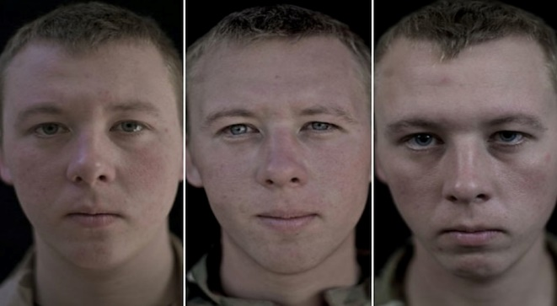

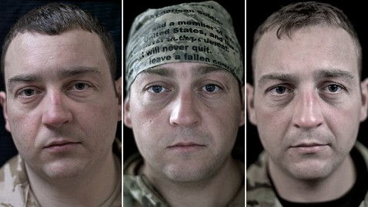

Spend no more than ten minutes on this activity. Below are a series of words. All of them are from the poem ‘Remains’. Complete the following activities as annotations around the hand:
- Make further predictions as to what the poem could be about based on the language you see.
- Pick THREE words from the hand and discuss their connotations.
- EXTRA CHALLENGE: Group some of the words you see into categories. I will not tell you what these categories should be. You have to decide for yourself!

INFERENCES FROM LANGUAGE

SUMMARISE THE INFORMATION
‘Remains’ is by Simon Armitage. Read the contextual information below. Reduce the information into four bullet points to help you understand what influenced Armitage’s writing. As you read, consider whether any of your inferences from the activities on the previous page were correct.

3.

4.

1.

2.

‘Remains’ appears in a poetry anthology by Simon Armitage called ‘The Not Dead’. ‘The Not Dead’ is a short collection of war poems written, not in battle, but as a response to the testimonies of ex-soldiers. Armitage also appeared in a documentary with the same name about ex-serviceman who are haunted by their experiences in war, although he has not been to war himself. As Simon Armitage points out in the introduction to this documentary, time is no "great healer" for people scarred by war. One of the former soldiers in the documentary is still unable to talk without crying about a jungle ambush he took part in nearly 50 years previously in Malaya. Each poem focuses on a flashback scene one of the ex-soldiers has struggled to forget. "Remains", for example, written for someone who served in Basra, tries to capture the moment when he shot a man looting a bank. The body was disposed of but the man's "blood shadow" remained on the street. Who are the Not Dead? The ex-servicemen and the ghosts trapped in their memories; the people who live and die and live again every time one of the veterans experiences a bad memory. This collection offers a strange, painful kind of memorial.

Activity #2 – Read the poem
. Read the poem and answer the questions that follow in full sentences. If you need help understanding the poem, try the LitCharts link. Do your best to answer the questions without extra help first before you look elsewhere for information: https://www.litcharts.com/poetry/simon-armitage/remains
201
15
10
Remains
On another occasion, we got sent out to tackle looters raiding a bank. And one of them legs it up the road, probably armed, possibly not.
Well myself and somebody else and somebody else are all of the same mind, so all three of us open fire. Three of a kind all letting fly, and I swear
I see every round as it rips through his life - I see broad daylight on the other side. So we've hit this looter a dozen times and he's there on the ground, sort of inside out,
pain itself, the image of agony. One of my mates goes by and tosses his guts back into his body. Then he's carted off in the back of a lorry.
End of story, except not really. His blood-shadow stays on the street, and out on patrol I walk right over it week after week. Then I'm home on leave. But I blink
1
5

and he bursts again through the doors of the bank. Sleep, and he's probably armed, and possibly not. Dream, and he's torn apart by a dozen rounds. And the drink and the drugs won't flush him out –
he's here in my head when I close my eyes, dug in behind enemy lines, not left for dead in some distant, sun-stunned, sand-smothered land or six-feet-under in desert sand,
but near to the knuckle, here and now, his bloody life in my bloody hands.
25

30

Activity #3 – Find it, Highlight it, Annotate it
- What is happening in this poem? Explain your ideas in no more than four sentences.

- Simon Armitage has transmuted the words of the soldiers. This means he has changed them into a different form. In this case, the form is poetry. Explain what the soldier in the poem is suffering from.

Spend no longer than thirty minutes on this activity. You may complete this activity by annotating the copy of the poem in this booklet OR in your poetry anthology if you have it with you. If you run out of space, feel free to print another copy of the poem off OR write on a different piece of paper. We will go through this again in class so please do not worry about missing anything. Complete the ‘find it, highlight it, annotate it’ task by looking at the line number each question directs you to, highlighting what is needed and answering the questions as annotations on your poem. If you miss any questions out, that’s fine BUT underline, circle or highlight ones you need to come back to later.
- Line 1 – Highlight ‘on another occasion’ – What does this suggest about the soldier speaking? What has he been

- Line 3 – Highlight ‘legs it up the road’ – How has Armitage created an authentic voice for the soldier here?

- Line 4 – Highlight ‘probably’ and ‘possibly’ – Why does Armitage create a sense of uncertainty as to whether the looter is armed? How is the soldier feeling?

- Line 5 – Circle ‘well’ and highlight the entire line – Why does Armitage include the word ‘well’ and why does the speaker refer to his fellow soldiers as ‘somebody else’? What has happened to their identities?

- Line 6 – Underline ‘all of the same mind’ – What does this tell us about how the soldiers are feeling?

- Line 8 – Highlight ‘letting fly’ – What does this tell us about the way the soldiers are firing their weapons?

- Line 8 – Nothing to highlight here – Look at how there is no punctuation at the end of the line. This is called enjambment. It means we do not have to pause and keep reading. Why do you think Armitage wants to keep the pace of the poem constant here?

- Line 9 – Highlight ‘rips through his life’ – What are the connotations of ‘rips’? What is the speaker saying about how he has killed the man he has shot?

- Line 10 – Highlight ‘broad daylight’ - What is the speaker saying here about the man once he has been shot? Why does Armitage include such violent imagery?
10. Line 12 – Highlight ‘sort of inside out’ – What image does Armitage create here and why does he create it?
11. Line 12 – You have already highlighted something in this line! – Explain how and why the soldier is unable to express himself properly.
12. Line 13 – Highlight the word ‘agony’ – Explore its connotations. What does it make you think of?
13. Line 15 – Highlight ‘tosses his guts back into his body’ – This is a horrible image but very casually said. What has happened to the soldiers for them to be so casual about violence?
14. Line 16 – Highlight this line – How much dignity is there in death in wartime?
15. Line 17 – Highlight this line – Why is this not the end of the story?
16. Line 18 – Underline ‘blood shadow’ – What could this be symbolic of?
17. Line 20 – Highlight ‘blink’ – Why is there no punctuation at the end of this line? Consider the action of ‘blinking’ and the action of bursting in line 21 to help you explain your point.
18. Lines 22-23 – Highlight the words ‘sleep’ and ‘dream’. – What is happening to the soldier now he is back home?
19. Line 24 – Highlight this line. – The speaker wants to ‘fix’ his mind but is using drink and drugs to do this. How is this ironic?
20. Line 24 – Circle the word ‘flush’ – What are the connotations of this word?
21. Lines 25-26 – Highlight ‘dug in’ – What is the speaker saying about this memory of the looter?
22. Line 26 – Underline ‘behind enemy lines’ – This is a military term. If you are ‘behind enemy lines’ you are in the territory of your enemy. Why does Armitage use this term to describe the speaker’s memory?
23. Lines 27-28 – Highlight every ‘s’ in these lines – Repeated ‘s’ sounds are called sibilance. In these lines the speaker is describing where the war was fought. Why use sibilance to do this?
24. Line 30 – Highlight this line – ‘Bloody’ could be the speaker swearing. Add this point to your notes and then explain what else ‘bloody’ could refer to.

Activity #4 – YouTube Analysis
This activity is optional but if you are aiming for a grade 6 or above, you should complete it if you have access to the internet. Follow this link: https://www.youtube.com/watch?v=hh2yeCz2LWY. It will take you to a video by ‘Mr. Salles Teaches English’ on YouTube. The ideas he discusses are complex but will help you consider the ideas needed for grades 7-9. Make notes in the grid below on each section of the video. Completing this activity will take you over your 90 minute slot BUT to achieve those higher grades, you MUST push yourself!

Tone | Allusion
Imagery | Form and Structure
Summarise your notes from the video into four key points:
1.

2.

3.

4.

Activity #5 – Themes
Themes:
Consider the ‘big ideas’ explored in Simon Armitage’s ‘Remains’. Pick the ones you think apply to the poem and briefly explain your choices below. Check your answers at the back of the booklet and adjust if necessary.

Individual Experience
Identity
Negative Emotions - Pride
Negative Emotions - Fear
Negative Emotions - Guilt
Negative Emotions - Anger
Power of Humans

Power of Nature

Effects of Conflict

Reality of Conflict

Loss and Absence

Memory

Briefly explain your choices in full sentences:
____________________________________________________________________________________________________________________________________________________________________________________________________________________________________________________________________________________________________________________________________________________________________________________________________________________________________________________________________________________________________________________________________________________________________________________________________________________________________________________________________________________________________________________________________________________________________________________________________________________________________________________________________________________________________________________________________________________________________________________________________________________________________________________________________________________________________________________________________________________________________________________

Activity #6 – Review your inferences

Consider the title ‘Remains’ again:

Remains

- Now you have read the poem, add notes explaining why you think it has the title ‘Remains’. Try and think of at least THREE ideas.
- This poem appears in the ‘Power and Conflict’ cluster of your GCSE anthology. Where are ‘power’ and ‘conflict’ seen in ‘Remains’? Try and avoid the obvious like ‘the soldier goes to war’. Add your notes around the title.

Activity #7 - EXTENSION
Finished everything? Have a look at this blog on ‘Remains’. It contains ideas we have not yet covered in the poem. Read it and make additional notes in the box below as to what you have learned: https://thestableoyster.wordpress.com/2019/01/29/a-sense-of-restraint-comments-on-armitages-remains/
Answers

Themes
These are the FIVE main themes that ‘Remains’ relates to. If you ticked something else, ensure you correct it in your booklet and amend your written answer too.

Individual Experience
Identity
Negative Emotions - Pride
Negative Emotions - Fear
Negative Emotions - Guilt
Negative Emotions - Anger
Power of Humans

Power of Nature

Effects of Conflict

Reality of Conflict

Loss and Absence

Memory

