The Sound of a Million hands Clapping

From Shetland to the Isles of Scilly, people stopped what they were doing and started clapping.
Every year on 11 November, Remembrance Day, we fall silent to remember those who have died in wartime.
But, on Thursday 26th March, we made a noise. A noise to celebrate the living fighting a different war – the thousands of health workers battling day and night to beat coronavirus.

Did you take part in this event? What was your motivation for taking part/ not taking part?

Is there a right and proper way to show respect and thanks? (Give reasons for you answer)

Campaigns like #clapforourcarers don’t make much of a difference. What our carers need right now is the right equipment, and for us to reduce pressure on the NHS by staying at home. Applause is superficial. There are more meaningful ways of showing you care – by telling someone your appreciation directly, for example. Source The Day 27/3/20
Write a response to this that argues that this act can be effective, why and how it is.

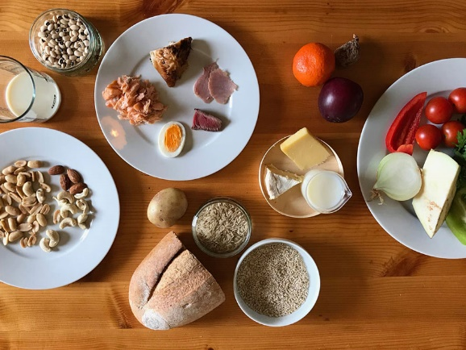

Much less meat and lots more vegetables!
That is what we should all be eating according to scientists who have assembled a new diet which could “transform” the future of planet Earth.
It could save millions of lives, feed billions and help avert environmental catastrophe. Introducing, the “planetary health diet”.
Based on detailed analysis, it presents what scientists believe is the best solution for keeping Earth’s population fed in an environmentally friendly way.
While meat would not be totally banned, for many it means eating a lot less. The plan allows the equivalent of one burger per week or one steak per month. Overall, the average European would have to eat 77% less red meat.
“The numbers for red meat sound small to a lot of people in the UK or US,” said Professor Walter Willet. “But they don’t sound small to the very large part of the world’s population that already consumes about that much or even less. It is very much in line with traditional diets.”
Two portions of fish and chicken a week would still be allowed (as well as the occasional egg), and you would eat a lot more nuts, vegetables and other plant-based foods.
Poor diet is one of the leading causes of mortality in the world, thought to be a factor in around 20% of all deaths. Researchers say this new diet could prevent 11 million deaths every year.
Then there is its potential environmental impact. Currently, food production is responsible for a quarter of all greenhouse gasses — more than all the world’s planes, trains, cars and ships combined. Scientists hope the “planetary health diet” will help cut emissions, save animals from extinction, and stop the expansion of farmland.

Green World
Working out the best diet for the planet is one thing, encouraging people to take it up is another. Should meat be taxed?
And what about going vegan? According to this diet, it is not about giving foods up entirely, but about moderation. When people argue that we should give up meat and dairy full stop, are they actually harming the environmental cause?
Could you follow this diet? (why)
“If everyone altered their diet, it would save the planet.”
“We should pay more for meat as it causes harm to the planet”
How far do you agree with the above statements and why?

No Greater love: the priest who gave his life
Is sacrificing one’s life the most powerful act of kindness?
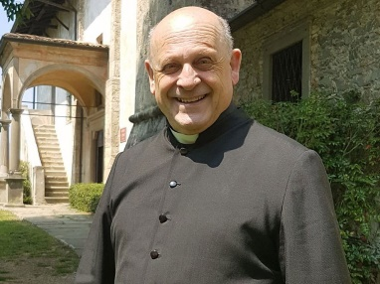
Reports say that an elderly priest in Italy gave up his respirator so that a younger man, a stranger, could survive the virus.
Last week, Father Giuseppe Berardelli, the main priest of Casnigo in Northern Italy, died in hospital. He was 72 years old and suffering from Covid-19.
According to the hospital in Lombardy – one of the places worst hit by coronavirus – his devoted parishioners had bought him a respirator to help him overcome the disease.
But he gave it to a younger patient he had never met in an act of incredible self-sacrifice.
Like thousands of others in Italy, Father Giuseppe Berardelli’s bout of Covid-19 sadly proved to be fatal.
At least 50 Italian priests have now been killed by the coronavirus. On Tuesday, Pope Francis led a prayer for the deceased, praising their “heroic example”.
However, one of Father Giuseppe’s friends has denied the respirator donation actually took place.
Nonetheless, the story is incredibly heart-warming and inspiring. It echoes other historical acts of great kindness.
Maximilian Kolbe, a Polish Franciscan friar imprisoned at Auschwitz, offered to be starved to death in the place of another man during a cruel Nazi punishment.
John Robert Fox, a US lieutenant during World War Two, drew German forces to his exact position before calling on his comrades-in-arms to drop artillery on him. This allowed allied troops to move to safety.
Is sacrificing one’s life the most powerful act of kindness?

True altruism
Yes. To give up one’s own life so that another can live is the ultimate act of generosity. It is an age-old storyline: from Luke Skywalker in The Last Jedi to Bing Bong in Inside out.
Then again, though emotionally powerful, sacrifice also reduces kindness to a single moment. A whole lifetime of virtue and care takes so much more effort and dedication. A single act of kindness can never be as powerful as years of generosity and benevolence.

According to the article, how had the priest ended up with the respirator?

How do you think his parishioners feel now and why?

What three emotions does this article inspire and why?

“To give up one’s own life so that another can live is the ultimate act of generosity”
Do you agree? Give reasons for your answer.
Give reasons why some people might disagree with you.
Include a religious view in your answer.

Find out about the NHS call for volunteers during the COVID-19 crisis.

Why do they need volunteers?
What do they need these volunteers to do?
Should we be encouraging people to deliver medicines etc to the houses of the vulnerable at times like this? Why?
If you were old enough to participate in this, would you, why?
Create a convincing plea for participation aimed at the 18-25 age bracket.

Is giving things up a good idea? During Lent, when Christians traditionally deprive themselves of something they enjoy. But the practice is common to other religions too.

It was Shrove Tuesday, and the woman making pancakes in her medieval kitchen had lost track of the time. Suddenly, she heard the church bells start to ring. “Help!” she thought. “I’m going to be late for the service!” And she rushed out of the house in such a panic that she forgot to take off her apron – and put down her frying pan.
This, according to tradition, is how pancake races started. The reason the woman was making pancakes was that for the 40 days of Lent, food such as eggs were forbidden, so they needed to be used up before it started.
For Christians, cutting down on enjoyable food is a commemoration of the 40 days Jesus spent fasting in the wilderness. St Francis is said to have spent the whole of Lent alone on an island in an Italian lake, living on half a loaf of bread.
Though many Christians now just give up one thing, such as alcohol, some – particularly in India and Pakistan – adhere to the ancient fast which forbids meat and dairy products and allows only one meal a day, eaten after sunset. In this, it strongly resembles the Muslim festival of Ramadan.
Such asceticism is important to other religions too. Hindus fast on certain days of the week and month, and during festivals such as Navaratri. The Buddha fasted so rigorously that he said, “My ribs stuck out like the rafters of an old hut,” before deciding on a more moderate form.
Jainism includes the idea of “santhara” (fasting to death) and around 200 followers are believed to end their lives in this way each year. Although it is intended only for those who are near death anyway, it is the subject of legal controversy in India where some regard it as attempted suicide.
In Judaism, self-denial can go beyond fasting: during Yom Kippur, it is forbidden even to brush your teeth. Extremely observant Jews refrain from using electrical devices, including TVs and computers, on the Sabbath.
The 21st-Century equivalent of a religion, some would argue, is wellness – and many of its practitioners advocate self-deprivation. The popular 5:2 diet is based on intermittent fasting, with five days of normal eating followed by two days restricted to just 500 calories.
Is giving things up a good idea?

Chewing it over
Some say that giving things up restores the natural balance in a world where many rich consumer societies enjoy massive excess. Our hunter-gatherer ancestors were used to feast or famine: if they killed a wild animal, they quickly ate it all. If food was scarce, they made do with little or nothing. And if we want to make life on the planet sustainable, we all need to cut back.
Others argue that it is not particularly healthy or scientific to live a yo-yo existence. The people who live longest have regular habits: they get up and go to bed at the same time every day, following the body’s natural rhythms, and have their meals at a set time, eating neither too much nor too little. They also stick to the same basic foods year in and year out.

Explain how this article contrasts with the recent behaviour of people we have seen in our supermarkets and shops.

What challenges do these types of fasts present to the followers of faith?

Why are followers prepared to make such sacrifices?

Could you give up the things you loved for 40 days? (why)

