GCSE English Language Revision – 200 Word Challenge (Paper 1, Question 5)
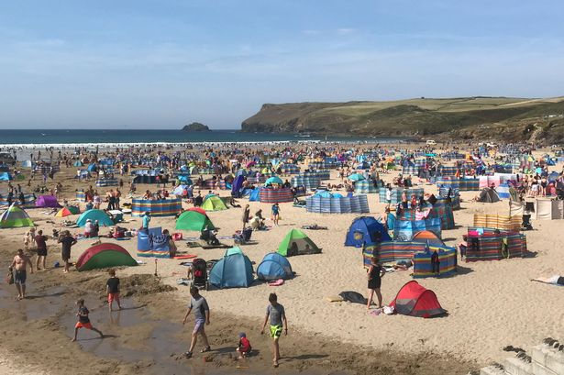
Your Challenge - Write a description inspired by the image. See if you can some of the following:
Stuck? Consider this:
- What has caused the annihilation? Are you in the middle of a war? Is the world ending?
- What was the setting like BEFORE this annihilation took place? Could you describe it?
- What can you see, hear or smell?
- a simile
- the word ‘iridescent’ (display of rainbow like colours)
- ambitious vocabulary
- a list of three
Remember, you only need to write around 200 words for this task. Focus on creating an effective, well-crafted piece of writing that includes a variation of sentences, full SPAG, a clear structure, description and techniques.
You could start:
The sun was burning bright as the beach found itself crowded with people. It was so busy, so packed that many people struggled to find a spot. Everyone seemed to be enjoying themselves whether they were flying kites or…
______________________________________________________________________________________________________________________________________________________________________________________________________________________________________________________________________________________________________________________________________________________________________________________________________________________________________________________________________________________________________________________________________________________________________________________________________________________________________________________________________________________________________________________________________________________________________________________________________________________________________________________________________________________________________________________________________________________________________________________________________________________________________________________________________________________________________________________________________________________________________________________________________________________________________________________________________________________________________________________________________________________________________________________________________________________________________________________________________________________________________________________________________________________________________________________________________________________________________________________________________________________________________________________________________________________________________________

