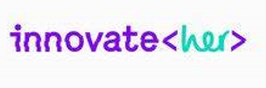
Go Digital: Phase 2
Monday 3rd-5th February 2020

Following the extremely successful Go Digital programme which students took part in last summer, Smithills students were invited to take part in phase 2.
In this part of the programme students were selected by the Go Digital Team having shown an aptitude for the Digital and Tech industry.

Four girls were invited to take part in the ‘Innovate Her’ programme whilst four other students were chosen for a ‘deep dive’ activity working on a more in depth design project developing their skills further . Both groups worked with professionals from the digital industry working to a design brief for a specific client.

The Deep Dive
Day one was spent taking part in a variety of workshops to develop and practice the skills needed to design, build and market their product.

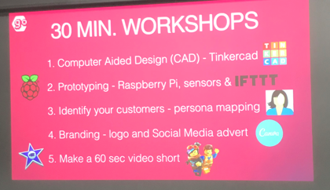
Workshops included

Students then chaired a meeting and took notes to create an ideas board having been introduced to the design brief below.
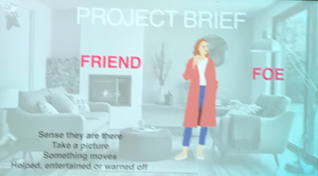

Students worked on designing a product that would sense someone is present in the home, it could be a friend or foe and either involve entertaining them or warding them off. The 3D design team were tasked with building their room idea using CAD. The video team produced a video of the development of the product. The Marketing team came up with a logo, slogan and name for the product whilst the tech team spent time developing the motion sensor to detect the intruder which sent an alert to a mobile and took a photograph. They built a model using lego to demonstrate how it would work.

Students also worked on designing a website to market their product and finally presented their work to the whole Go Digital team and other business people working within Federation House in Manchester.

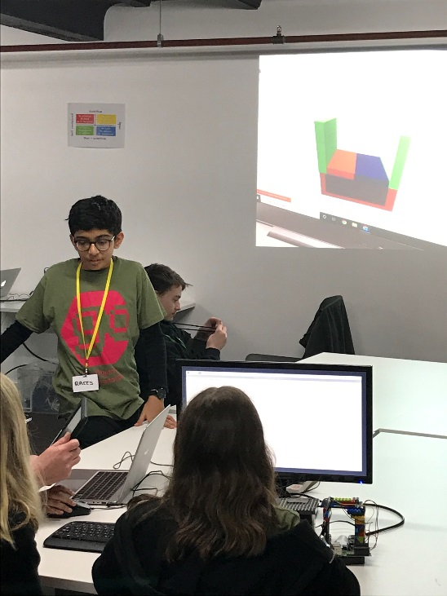
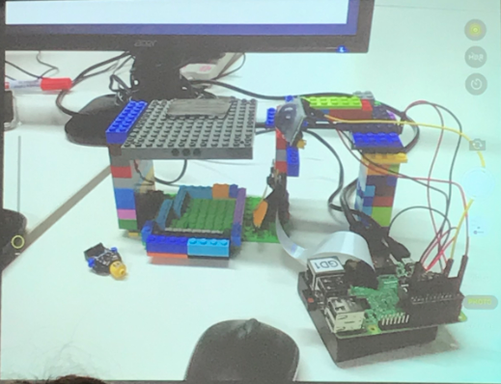

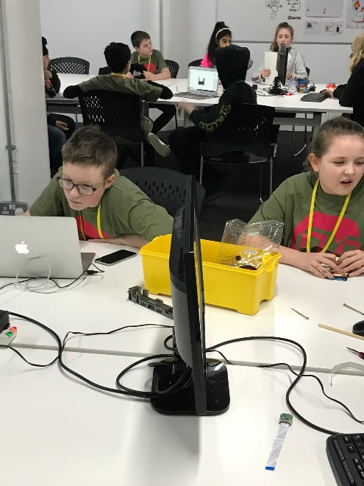

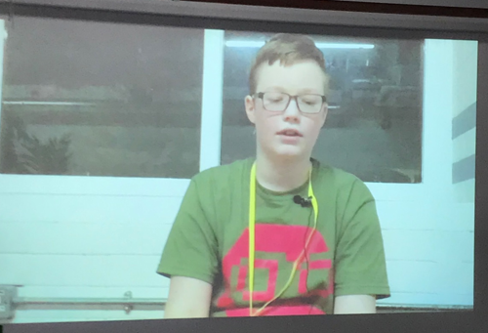

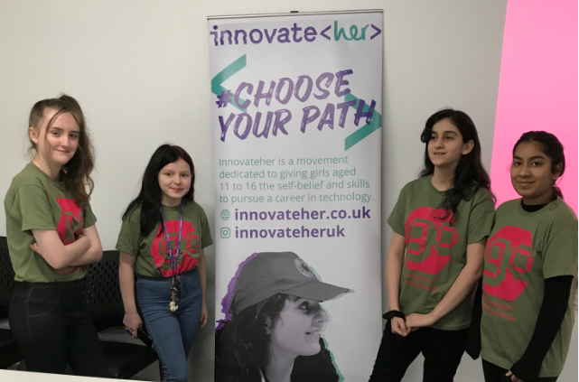

The vision for Innovate Her is to achieve gender equality in technology and their mission to support girls in getting into the tech industry, since businesses will thrive where there is a diverse team working together.

The girls working with the innovate her team started the programme learning about the importance and power of technology. They were introduced to product design and spent time researching Alder Hey Children’s Hospital who became their clients. Students learned valuable skills in sketching, wire framing and developing a prototype. They were tasked with designing an app that would solve an issue faced by their client Alder Hey Children’s Hospital. Students developed a persona of the user of the App to help them develop specific key features. They also learned about the importance of planning and working through each stage of the process to produce a final product.

Day two was spent developing their app and on the final day the girls learned key techniques in pitching their concept and presenting their ideas to an audience.
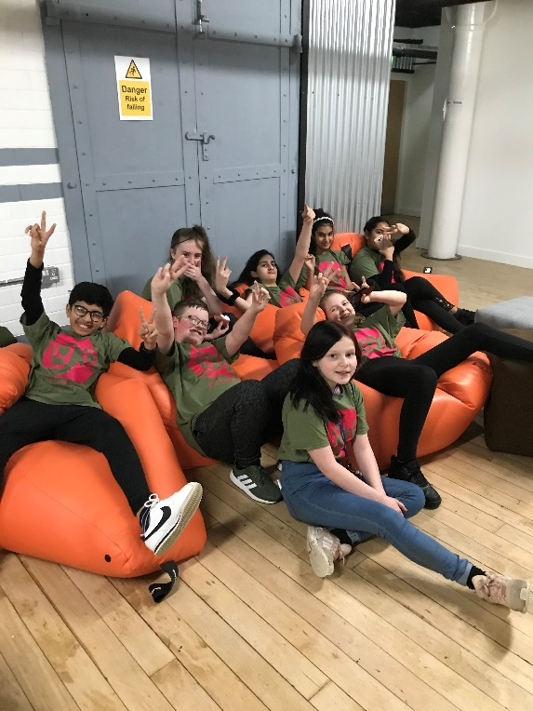
All students throughout the programme developed important employability skills including team work, working to deadlines, communication, problem solving, researching, planning and organisation; as well as develop their technical and digital skills. It was incredible to see their confidence grow, taking on different challenges as they became more willing to step out of their comfort zone and also willing to help others in their team. They were able to see how real businesses operate and gained a real appreciation of their personal skills and interests which will help them identify careers areas of interest within the digital and tech industry in the future.

A brilliant three days! Thank you to the whole GO Digital team!!

