- You need to register for an account (its free) if you haven’t already got one www.senecalearning.com

- Complete the details on the signup page

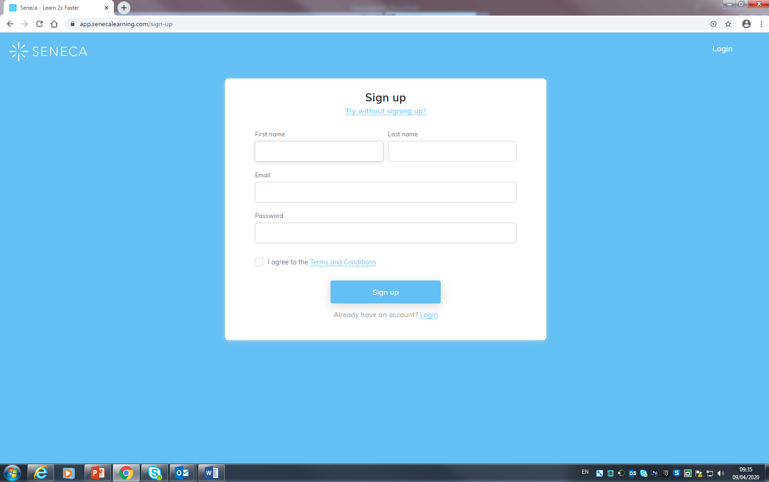

- Click on the button that shows you are a student
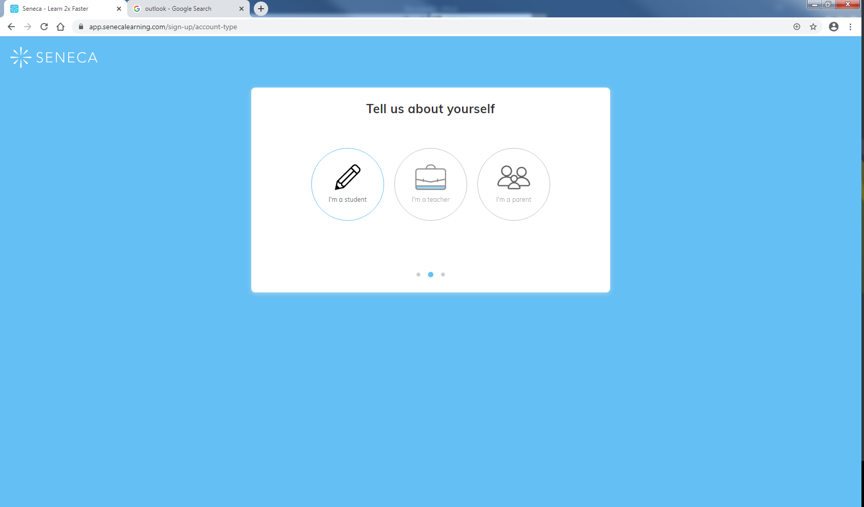

- On the next page type the school name in. It should show our school in the drop down box. Click the consent button if you are over 13, if you are not check with an adult that its ok for you to use it.

- On the next page click “Classes & Assignments”.

- Now click join class

- It will then ask you to enter a class code. This is the code that is written next to your subject/year group (on the Emergency work area of the school website)

