YEAR 9
REMOTE LEARNING ACTIVITIES
POWER AND CONFLICT POETRY

Name:
Class:
Teacher:

This booklet has been designed to help you learn the poems in the AQA Power and Conflict cluster from your poetry anthology at home. Work your way through the activities in the booklet. You can fill these out on the computer or print the booklet off and hand write your answers. On various pages there will be directions to other resources you can find online to help you with your studies. If you do not have access to a computer, please do not worry! The most important things you need to know have been set out for you here.

‘BAYONET CHARGE’

Bayonet Charge
This session will be based around ‘Bayonet Charge’ by Ted Hughes. Some of the activities will require you to make notes in this booklet or on a different piece of paper. When you begin to annotate the poem, you can do this in your copies of the poetry anthology if you wish. We will go through these poems again in class when you return to address any misconceptions you might have made. If you have any questions, email your teacher who will get back to you as soon as they can.
Spend no more than five minutes on this activity. Consider the title of the poem. Predict what big ideas the poem will explore by completing the following activities. Write your answers as annotations around the title.
- What is a ‘bayonet’?
- This poem is about an individual’s battle in war. As part of the ‘Power and Conflict’ anthology, what messages about war do you think will be presented? Think carefully about the choice of ‘charge’.
- Using the notes you have made and the information I have already given you about the poem, explain what ‘big ideas’ you think ‘Bayonet Charge’ will explore.

Activity #1 – Pre-reading activities
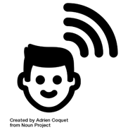
MAKE PREDICTIONS

Bayonet Charge
INFERENCES FROM IMAGES
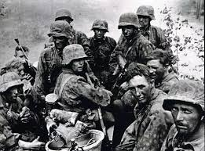
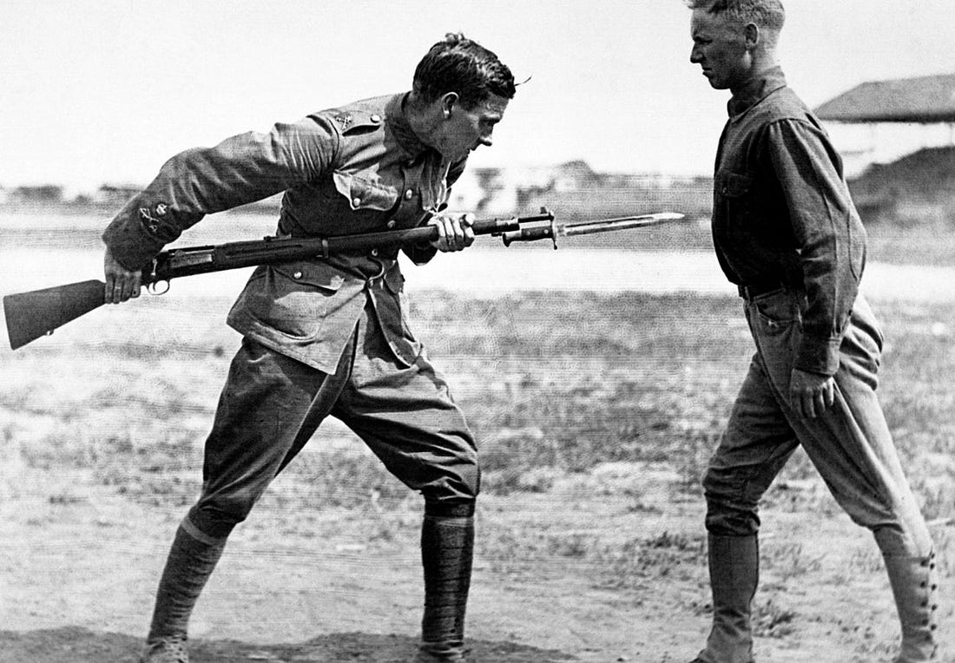
The photos below show the soldiers fighting in World War 2 and some of the weaponry that they would have used:
- Consider the physical impact that fighting would have had on these soldiers. How do these images support this?
- How do you think a soldier would be feeling when they went ‘over the top’ of the trenches?
- How do these pictures contradict propaganda at the time?

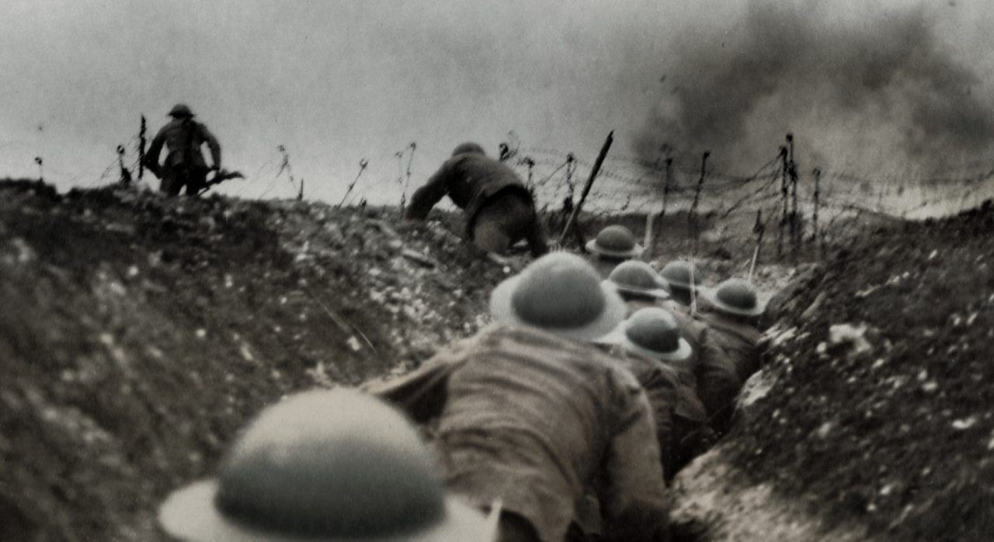

Spend no more than five minutes on this activity. ‘Bayonet Charge’ is by Ted Hughes. Read the contextual information below. Reduce the information into four bullet points to help you understand what influenced Hughes’ writing. As you read, consider whether any of your inferences from the activities on the previous page were correct.

SUMMARISE THE INFORMATION
Hughes writes about the elements and aspects of the natural world in much of his poetry. The poet Simon Armitage (writer of ‘Remains’) said that for Hughes, poetry was ‘a connecting rod between nature and humanity’.
This poem seems to be heavily influenced by the fact that Hughes’ father was a veteran of the First World War (having survived his regiment’s massacre at Gallipoli), as well as by the poetry of Wilfred Owen (writer of ‘Exposure’). Ted Hughes served in the RAF, but he did not see combat. He spent much of his time in the services reading.
The poem itself is about a nameless soldier going over the top in the trenches. Soldiers would have bayonets attached to the end of their rifles and would use them to stab enemy soldiers. The nameless soldier in the poem seems to become more weapon than man, rushing towards the enemy. It is not clear at the end whether he dies but there is definitely a change in him. His actions are very raw and primal, much like an animal, suddenly pausing, preparing to react.

3.

4.
1.

2.

Activity #2– Tier 2 Vocabulary
Spend no longer than ten minutes on this section. Complete the following activity on vocabulary that will come in useful when writing about ‘Bayonet Charge’ in an essay.
The poem is centred around a patriotic soldier who is fighting in the war to try and protect his country.
Use the term correctly in a sentence:

Write a new definition in your own words:

patriotic
expressing devotion to one’s country

Write a question where the word is the answer:

Think of other words that mean the same thing (synonyms) and make a list below:

Drawn an icon/symbol to illustrate the key word:

Activity #3 – Read the poem
Spend no longer than ten minutes on this activity. Read the poem and answer the questions that follow in full sentences. If you need help understanding the poem, try the LitCharts link. Do your best to answer the questions without extra help first before you look elsewhere for information: https://www.litcharts.com/poetry/ted-hughes/bayonet-charge
Bayonet Charge
Suddenly he awoke and was running – raw
In raw-seamed hot khaki, his sweat heavy,
Stumbling across a field of clods towards a green hedge
That dazzled with rifle fire, hearing
Bullets smacking the belly out of the air –
He lugged a rifle numb as a smashed arm;
The patriotic tear that had brimmed in his eye
Sweating like molten iron from the centre of his chest,

In bewilderment then he almost stopped –
In what cold clockwork of the stars and the nations
Was he the hand pointing that second? He was running
Like a man who has jumped up in the dark and runs
Listening between his footfalls for the reason
Of his still running, and his foot hung like
Statuary in mid-stride. Then the shot-slashed furrows

Threw up a yellow hare that rolled like a flame
And crawled in a threshing circle, its mouth wide
Open silent, its eyes standing out.
He plunged past with his bayonet toward the green hedge,
King, honour, human dignity, etcetera
Dropped like luxuries in a yelling alarm
To get out of that blue crackling air
His terror’s touchy dynamite.

1

5

10

15

201

- What is happening in this poem? Explain your ideas in no more than four sentences.

- Why do you think that it is important that the soldier is not named within this poem?

- What do you think this poem is revealing about how the government treated the soldiers in World War 2? Use a quote to support your ideas.

Activity #4 – Clarifying tricky vocabulary
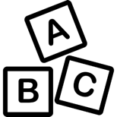
Spend no longer than twenty minutes on this activity. Some of the words from the poem are quite complex. Write the definitions for each word and explain what they mean in the poem’s context. Look at the example below to help you. Once you have finished adding your definitions, check the answers in the back of the booklet immediately to avoid any errors and misconceptions. There will be a chance for you to visually represent each word at the end of this activity as well. Not every complicated word is in this grid. I have only chosen the main ones for you.

CLARIFY TRICKY VOCABULARY
Word | Add the definition | Read the word in context | What does the line mean?
clods | Lumps of earth. | ‘Stumbling across a field of clods towards a green hedge’ | The land was ruined and was very hard to travel across, even if it was an emergency.
statuary |  | ‘foot hung like  Statuary in mid-stride’
threshing |  | ‘Threw up a yellow hare that rolled like a flame And crawled in a threshing circle’
molten |  | ‘Sweating like molten iron from the centre of his chest’
bewilderment |  | ‘In bewilderment then he almost stopped’
furrows |  | ‘Then the shot-slashed furrows’
Extension: Create an icon (visual representation) of each word in the space below to help your understanding of the language used in the poem.

Activity #5– Find it, Highlight it, Annotate it
Spend no longer than thirty minutes on this activity. You may complete this activity by annotating the copy of the poem in this booklet OR in your poetry anthology if you have it with you. If you run out of space, feel free to print another copy of the poem off OR write on a different piece of paper. We will go through this again in class so please do not worry about missing anything. Complete the ‘find it, highlight it, annotate it’ task by looking at the line number each question directs you to, highlighting what is needed and answering the questions as annotations on your poem. If you miss any questions out, that’s fine BUT underline, circle or highlight ones you need to come back to later.
The poem starts in the middle of the action, this is called in media res, it is clear that the soldier is exhausted from the constant fatigue of war.
Suddenly he awoke and was running – raw
In raw-seamed hot khaki, his sweat heavy,
Stumbling across a field of clods towards a green hedge
That dazzled with rifle fire, hearing
Bullets smacking the belly out of the air –
He lugged a rifle numb as a smashed arm;
The patriotic tear that had brimmed in his eye
Sweating like molten iron from the centre of his chest,

1. Why does the poem begin with the word suddenly? What is the effect? What does this reveal about the life of a soldier?
2. How does Hughes make the poem a microcosm for ALL the soldiers’ experiences? Which word in particular is used?
3. The poem has an irregular rhythm meaning it can be difficult to read. What could this mirror?
4. Why mention the hedge is ‘green’? Considering the effects of war, what is the significance of this ‘green hedge’?
5. What are the connotations of the verb ‘dazzled’? What do these connotations reveal?
6. What does the phrase ‘patriotic tear’ reveal about the soldier?
7. Identify the simile in this stanza. What is the effect?
8. The poet uses enjambment in this stanza. What is the effect?
9. How does Hughes dehumanise the soldier in the last line?

The poem then draws our attention to the dangers the soldiers would experience in war, not only are they physically exhausted, but they are also mentally exhausted from constantly having to fear death and the sounds of weapons.
In bewilderment then he almost stopped –
In what cold clockwork of the stars and the nations
Was he the hand pointing that second? He was running
Like a man who has jumped up in the dark and runs
Listening between his footfalls for the reason
Of his still running, and his foot hung like
Statuary in mid-stride. Then the shot-slashed furrows

1.Why is the soldier bewildered? What does this reveal?
2. Why does Hughes decide to use a dash at the end of the first line?
3. Hughes creates the image of a clock. What is the effect of this?
4. How does the metaphor of ‘stars’ and ‘nations’ create a sense of authority? Consider the idea of celestial imagery. Why describe this authority as cold?
5. Identify a rhetorical question. How does this influence the tone of the poem?
6. Hughes does not make the reason for his running explicit. What is the effect of this?
7. The poet uses enjambment in this stanza. What is the effect of this?
8. Identify the sibilance in this stanza? What is the effect of this?
The final stanza brings us back into the action again; here the soldier is participating in the battle and realising that all of the reasons he was told to join war were in fact lies (propaganda) to convince him war would be fun.
Threw up a yellow hare that rolled like a flame
And crawled in a threshing circle, its mouth wide
Open silent, its eyes standing out.
He plunged past with his bayonet toward the green hedge,
King, honour, human dignity, etcetera
Dropped like luxuries in a yelling alarm
To get out of that blue crackling air
His terror’s touchy dynamite.

1. Identify the simile in this stanza. What is the effect?
2. What are the connotations of the verb ‘threshing’? What image does this verb create?
3. What does the verb ‘plunge’ reveal?
4. The structure of this stanza means the ‘green hedge’ stands out again because it is the longest line. Why does Hughes want to draw our attention to it again?
5. What is the soldier feeling when he says, ‘King, honour, human dignity, etcetera’? Panic? Fear? Frustration? Why is the soldier so dismissive of these three things?
4. What is the effect of the alliteration in the last?
5. The poem focusses on one soldier. What is the effect of this?
6. What is the last line suggesting about the soldier’s emotions? Consider the noun ‘dynamite’ and its connotations.
Activity #6– Further contextual information
Spend no longer than ten minutes on this section. Having read the poem, we have established that it is about a soldier who is battling within the war. However, the poem contains a specific image of a ‘yellow hare’ which is very important to your understanding of the poem. Complete the task below.
Highlight THREE points maximum in this paragraph that helps you to understand the relevance of the ‘yellow hare’ in the poem.

The hare, traditionally a swift-moving animal who could easily outrun a man, is passive here, 'thrown up' by the earth, and instead of running, it 'rolled like a flame / And crawled in a threshing circle'. Against the field across which the soldier runs, it seems brightly coloured and yellow (hares are usually a light brown colour). It seems to be clearly injured, the word 'threshing' particularly suggesting its pain, but it is silent. It could be argued that the horrible silent scream suggested by 'its mouth wide/ Open silent' seems to foretell the soldier's fate if he stays still. Hares often rely on their colour to camouflage themselves against predators, and will therefore lie still in fields unless disturbed, this is when they run in their characteristically zig-zag fashion to elude pursuit (like a soldier trying to dodge bullets, one might think). For Hughes (and more importantly, for the soldier he is writing about ) a running hare like this would have been a familiar sight. However, the hare wounded and thrashing about on the ground, would have been a very vivid reminder of what injury you could get by staying still. Similarly, the colour yellow is linked to cowardice, another sign of what could happen to you if you were a coward in a battle.

1.

2.

3.

Activity #6 – YouTube Analysis
This activity is optional but if you are aiming for a grade 7 or above, you should try and complete it if you have access to the internet. Follow this link: https://www.youtube.com/watch?v=0AdamMI7h24. It will take you to a video by ‘Mr. Salles Teaches English’ on YouTube. The ideas he discusses are complex but will help you consider what is needed for grades 7-9. You DO NOT need to watch the entire video but you can if you want. Pay particular attention to the topics in the grid and make notes. I have provided the times for you.

Structure (0:50 – 5:16) | Simile (5:17 – 12:42) and Metaphor (12:43-21:30)
Symbolism (21:31 – 27:56) | Sound (27:57 – 35:08)
Summarise your notes from the video into four key points:
1.

2.

3.

4.

Activity #7 – Themes
Spend no longer than ten minutes on this section.
Themes:
Consider the ‘big ideas’ explored in Ted Hughes’ ‘Bayonet Charge’. Pick the top five that you think apply to the poem and briefly explain your choices below. Check your answers at the back of the booklet and adjust if necessary.

Individual Experience
Identity
Negative Emotions - Pride
Negative Emotions - Fear
Negative Emotions - Guilt
Negative Emotions - Anger
Power of Humans

Power of Nature

Effects of Conflict

Reality of Conflict

Loss and Absence

Memory

Briefly explain your choices in full sentences:
____________________________________________________________________________________________________________________________________________________________________________________________________________________________________________________________________________________________________________________________________________________________________________________________________________________________________________________________________________________________________________________________________________________________________________________________________________________________________________________________________________________________________________________________________________________________________________________________________________________________________________________________________________________________________________________________________________________________________________________________________________________________________________________________________________________________________________________________________________________________________________________

Answers

Vocabulary
Mark your answers to the vocabulary activity. Your definition does not need to be worded exactly as it is here but you should be able to tell whether you have the correct answer or not.

CLARIFY TRICKY VOCABULARY

Word | Add the definition | Read the word in context | What does the line mean?
clods | Lumps of earth. | ‘Stumbling across a field of clods towards a green hedge’ | The land was ruined and was very hard to travel across, even if it was an emergency.
statuary | A group of statues. | ‘foot hung like  Statuary in mid-stride’ | The soldier is frightened to move, he is surveying all of the sounds around him to see what dangers are present.
threshing | Thrashing, or the beating of crops to separate the crop from the straw. | ‘Threw up a yellow hare that rolled like a flame And crawled in a threshing circle’ | Suggestive of how war can also affect nature, making it flat and powerless.
molten | A metal that is liquified by heat. | ‘Sweating like molten iron from the centre of his chest’ | The soldier is in extraordinary pain, he feels like his insides are burning to the point of destruction.
bewilderment | A feeling of being confused. | ‘In bewilderment then he almost stopped’ | The soldier is experiencing so many things at once that he is confused as to what to lay his focus on, he is overwhelmed.

Themes
These are the FIVE main themes that ‘Bayonet Charge’ relates to. If you ticked something else, ensure you correct it in your booklet and amend your written answer too.

Individual Experience
Identity
Negative Emotions - Pride
Negative Emotions - Fear
Negative Emotions - Guilt
Negative Emotions - Anger
Power of Humans

Power of Nature

Effects of Conflict
Reality of Conflict

Loss and Absence

Memory

